READ ME BRIEF 1

Videos used for Brief 1:

<https://youtu.be/aBzpvUXibw0>

[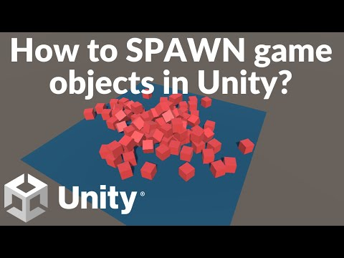](https://www.youtube.com/embed/aBzpvUXibw0?feature=oembed)

<https://youtu.be/NWJM87xMmLE>

[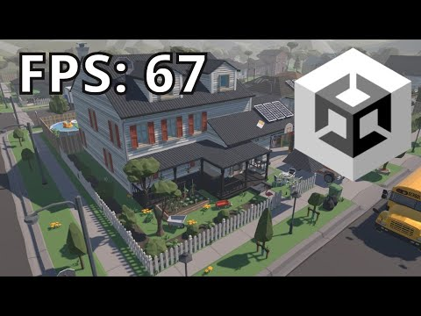](https://www.youtube.com/embed/NWJM87xMmLE?feature=oembed)